**KAZ_FILLERS**

**https://pin.it/7haDCeLU0**

**Filler 1:**

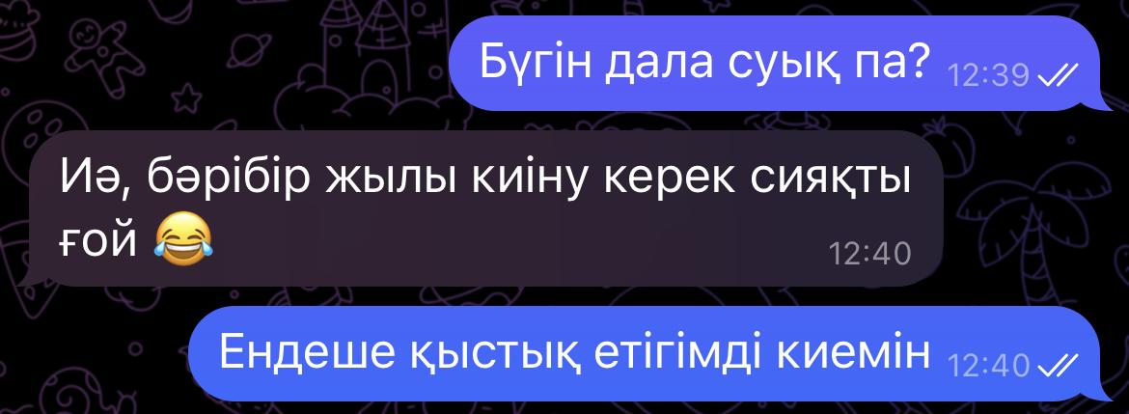

Translation:

Speaker A: Is it cold outside today?

Speaker B: Yes, it seems as if you need to wear warm clothes anyway 😂

Speaker A: Then I will wear my winter boots

Question: Is person A going to wear winter boots?

**Filler 2:**

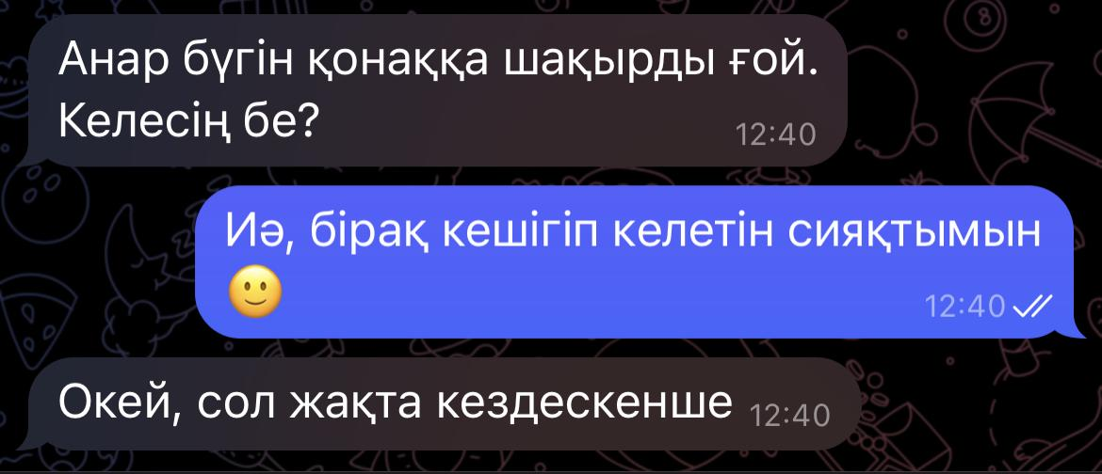

Translation:

Speaker A: Anar invited us for today. Will you come?

Speaker B: Yes, but I will be late. 🙂

Speaker A: Okay, then see you there

Question: Will person B be late?

**Filler 3:**

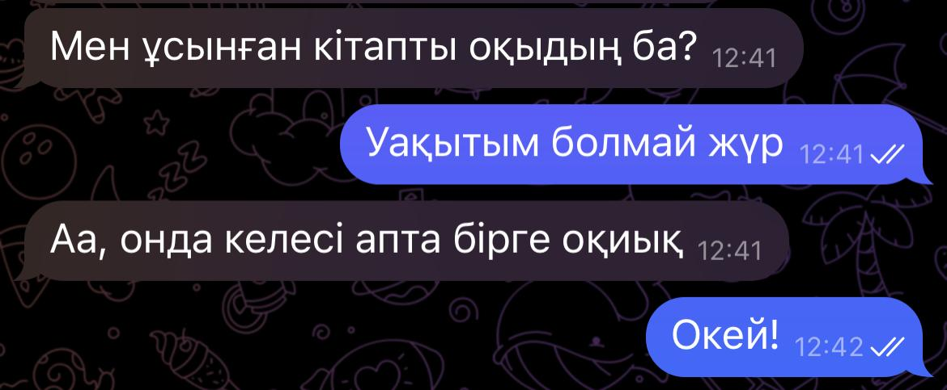

Translation:

Speaker A: Have you read the book that I recommended?

Speaker B: I haven’t had time

Speaker A: Oh, then we could read it together next week

Speaker B: Okay!

Question: Does Speaker B not have time?

**Filler 4:**

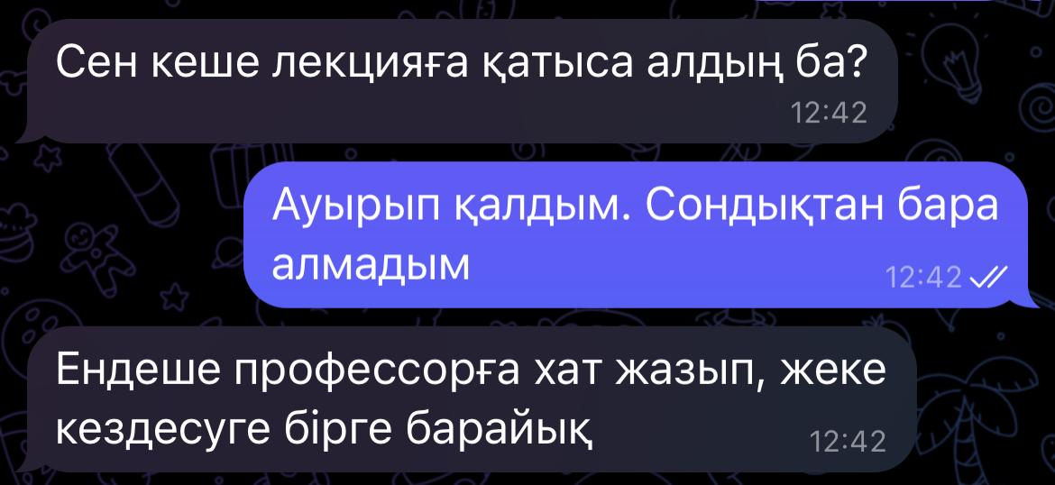

Question: В лекцияға бара алды ма?

Translation:

Speaker A: Did you attend the lecture yesterday?

Speaker B: I got ill. So could not go to the lecture

Speaker A: Then let’s write an email to professor and meet him personally

Question: Did B go to the lecture?

**Filler 5:**

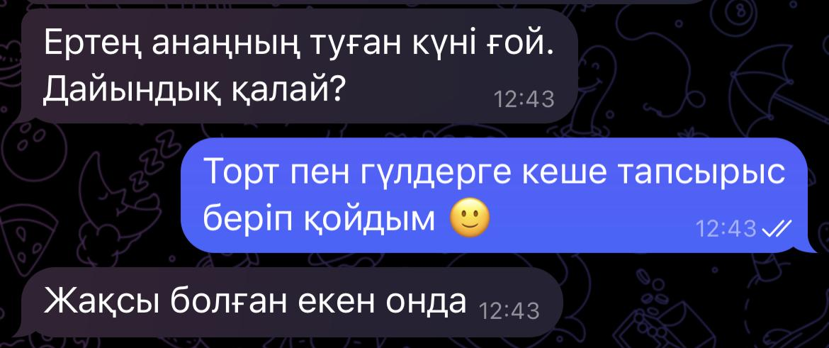

Translation:

Speaker A: Tomorrow is your mother’s birthday. How is the preparation going?

Speaker B: I made an order for a cake and flowers yesterday🙂

Speaker A: That’s good then

Question: Did B order a cake and flowers?

**Filler 6:**

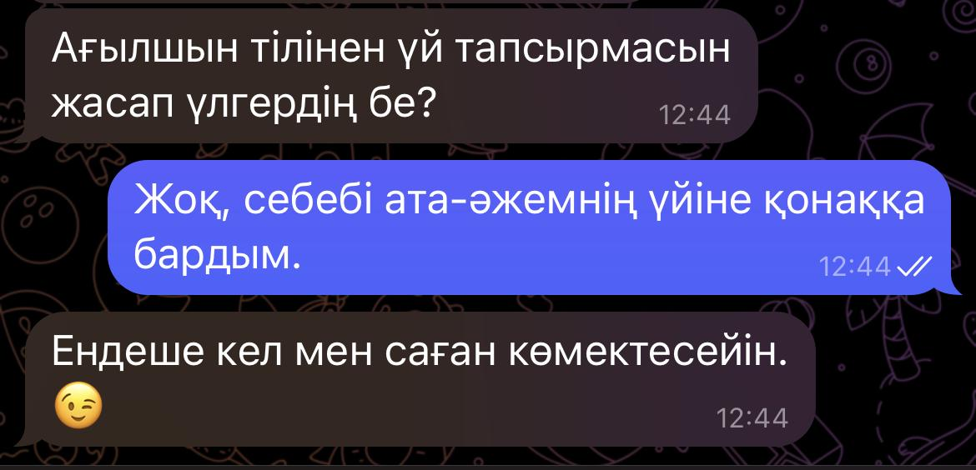

Question: B үй тапсырмасын жасады ма?

Translation:

Speaker A: Were you able to finish your homework on the English language on time?

Speaker B: No, I was a guest at my grandparents’ house

Speaker A: Then let me help you.😉

Question: Did B do homework?

**Filler 7:**

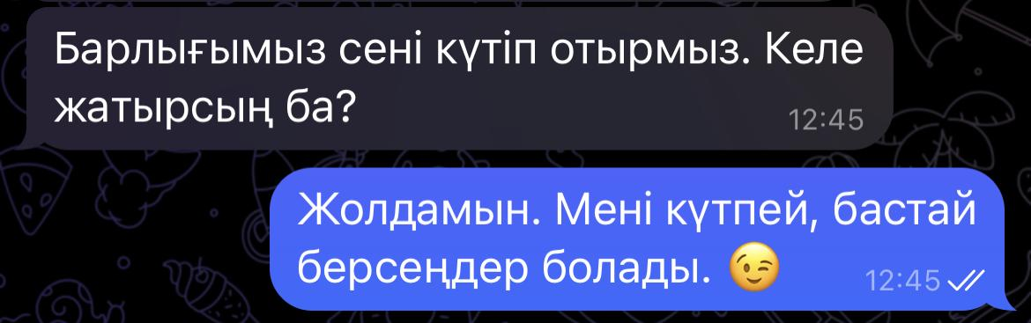

Question: А B-ны күтуі қажет пе?

Translation:

Speaker A: We are all waiting for you. Are you coming?

Speaker B: I am on my way. You can start without waiting for me. 😉

Question: Do A need to wait for B?

**Filler 8:**

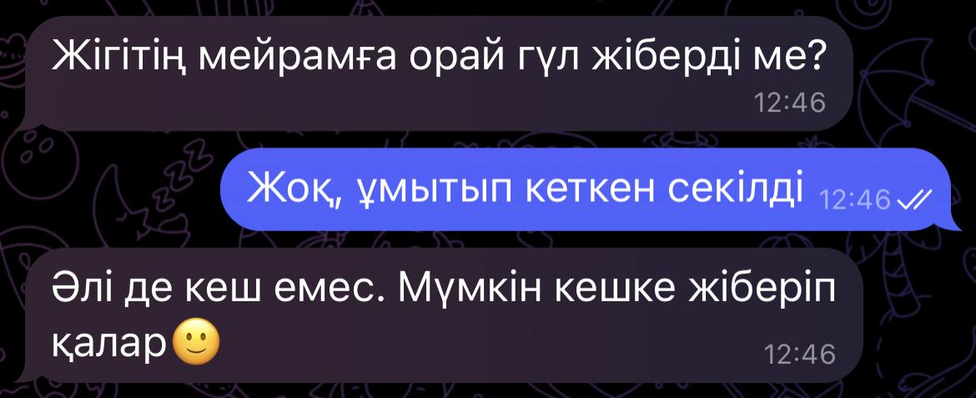

Question: B мейрамға орай гүл алды ма?

Translation:

Speaker A: Did your boyfriend send you flowers in honor of the holiday?

Speaker B: No, it seems as if he forgot

Speaker A: It’s not too late. Maybe he will send them in the evening. 🙂

Question: Did B receive flowers in honor of the holiday?

**Filler 9:**

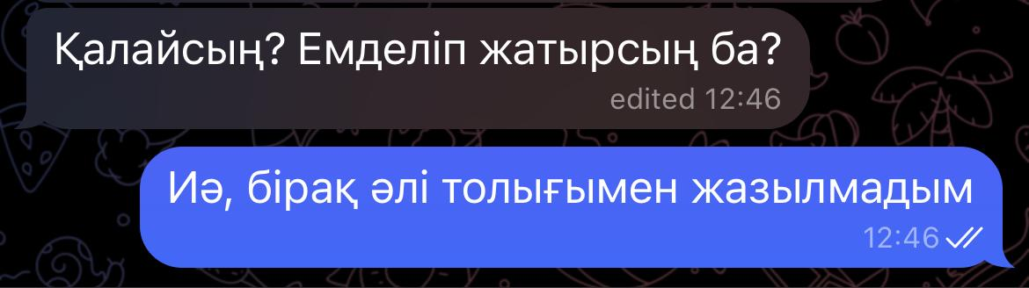

Question: B жазылды ма?

Translation:

Speaker A: How are you? Are you still undergoing treatment?

Speaker B: Yes, but I haven’t recorded fully yet

Question: Has B recovered yet?

**Filler 10:**

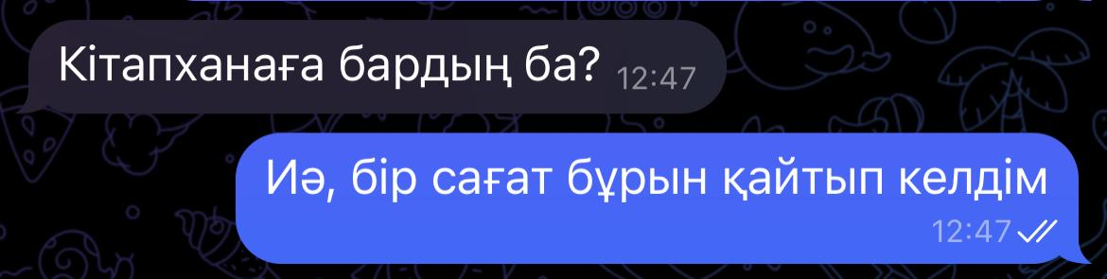

Question: В кітапханаға барды ма?

Translation:

Speaker A: Did you go to the library?

Speaker B: Yes, I came back an hour ago

Question: Did B go to the library?

**KAZ_STIMULI**

**Without emoji (2)**

**Mild:**

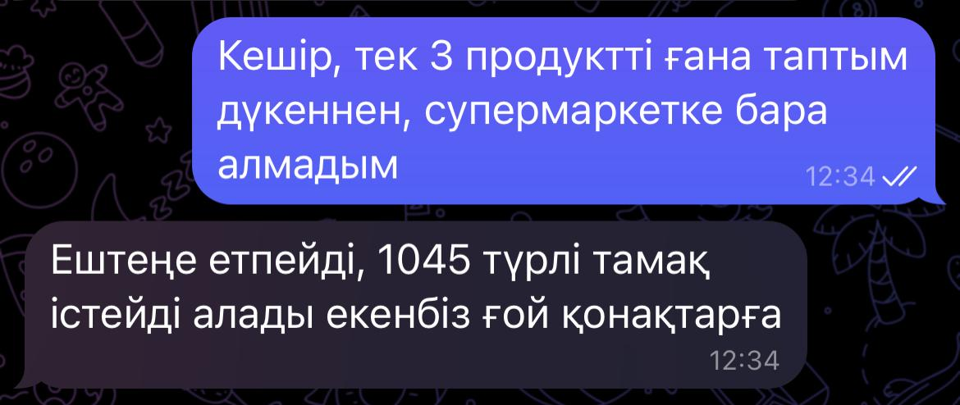

Question: В А алған продукттерден көп тамақ істей алады деп ойлайды ма?

[Expected answer: Жоқ]

Translation:

[А]: Sorry, I could find only three products at the store, I couldn’t go to a supermarket

[В]: That’s fine, seems like we can prepare 1045 kinds of food from the products for quests

Question: Does B think they can prepare different kinds of food for guests?

[Expected answer: No]

**Strong:**

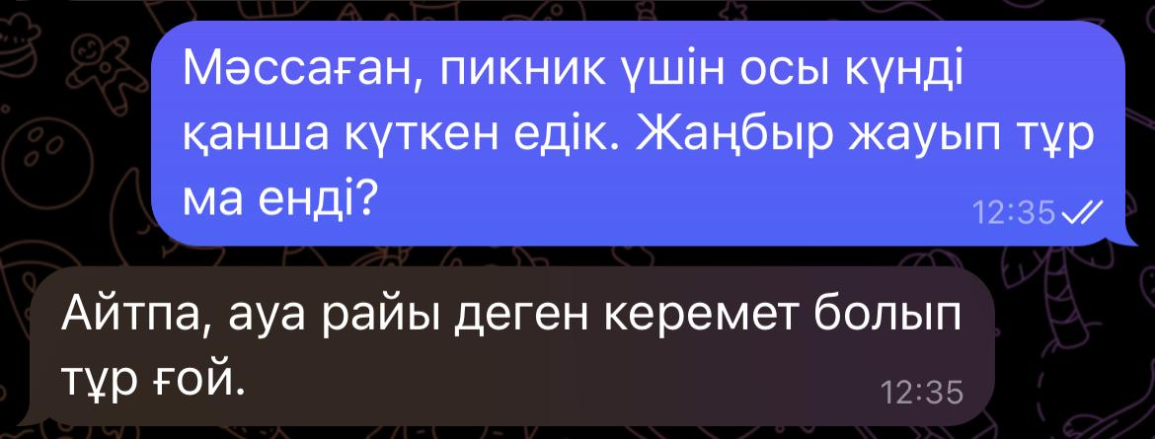

Question: B ауа райына қуанышты ма?

[Expected answer: Жоқ]

Translation:

[A]: We waited so long for this day to go on a picnic, and it’s raining now?

[B]: Don’t mention, the weather is really amazing today.

Question: Is B happy for the weather?

[Expected answer: No]

**With emoji 🙂 (2)**

**Mild**

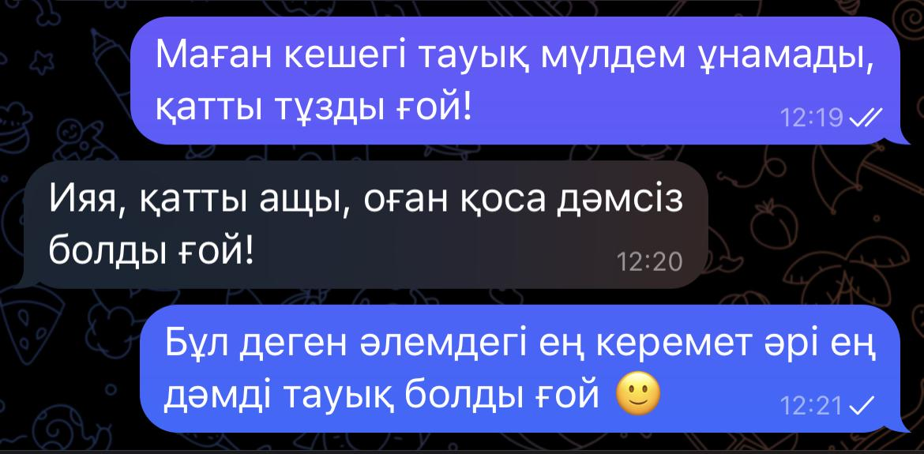

Question: С достарымен келіседі ме?

[Expected answer: Иә]

Translation:

[A]: I didn’t like yesterday’s chicken at all, it was so damn salty!

[B]: Yeah, too spicy, and plus it wasn’t even tasty!

[С]: Indeed, it was the best and tastiest chicken ever 🙂

Question: Does C agree with his friends?

[Expected answer: Yes]

**Strong:**

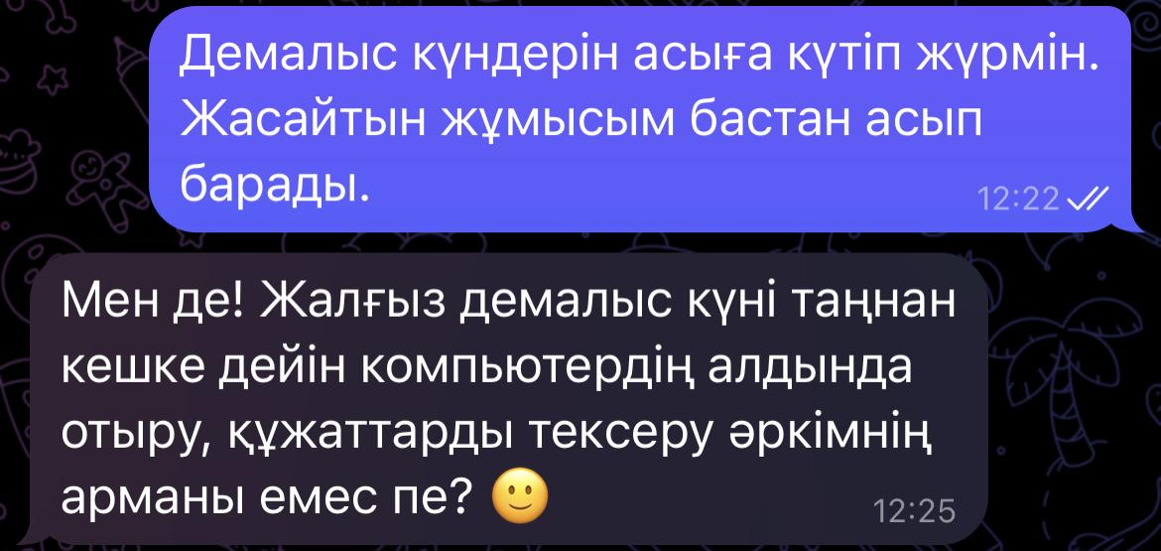

Question: B демалыс күндерін асыға күтіп жүр ме?

[Expected answer:Жоқ]

Translation:

Speaker A: I can’t wait for the weekend. I have a lot of work to do.

Speaker B: Me too! Isn’t it everybody’s dream to spend your only weekend sitting in front of the computer and checking the documents? 🙂

Question: Can’t B wait for the weekend?

[Expected answer:No]

**With Emoji 😂(2)**

**Mild:**

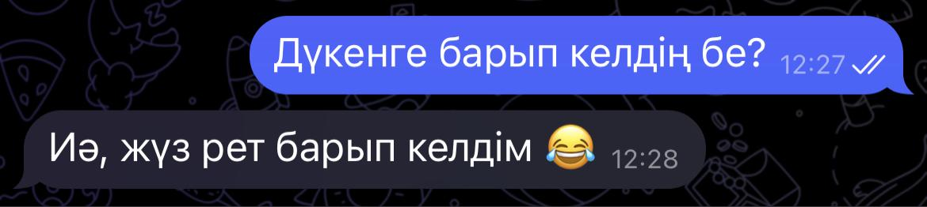

Question: В дүкенге барды ма?

[Expected answer: Жоқ]

Translation:

Speaker A: Did you go to the grocery?

Speaker B: Yes, I have gone there 100 time😂

Question: Did B go to the grocery?

[Expected answer: No]

**Strong:**

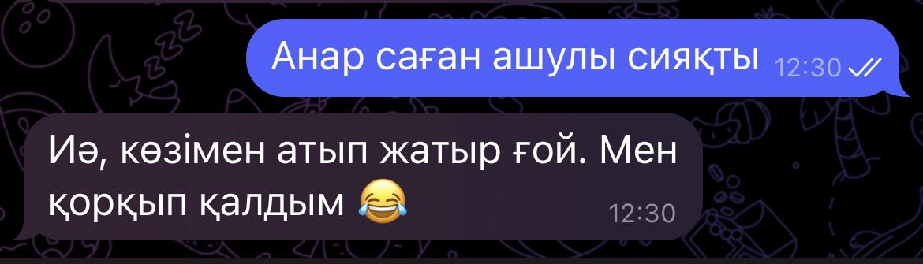

Question: B қорқып қалды ма?

[Expected answer: Жоқ]

Translation:

Speaker A: It seems as if Anar is angry with you

Speaker B: Yes, she is shooting me with her eyes. I am afraid now

Question: Is B afraid of Anar?

[Expected answer: No]

**With Emoji 😉 (1)**

**Mild:**

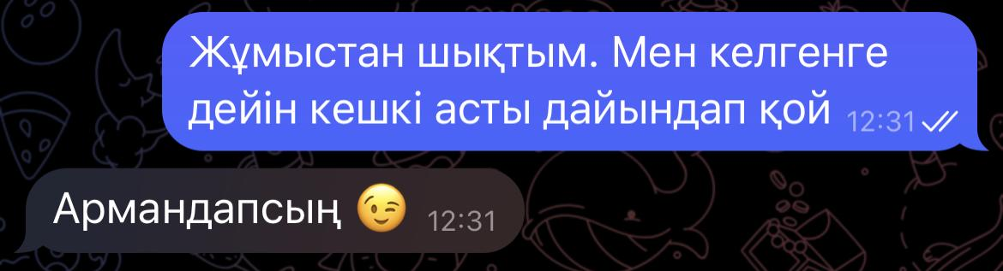

Question: B кешкі асты дайындайды ма?

[Expected answer: Жоқ]

Translation:

Speaker A: I left the workplace. Prepare the dinner before I will come home

Speaker B: In your dreams **😉**

Question: Will B prepare the dinner?

[Expected answer: No]

**Strong:**

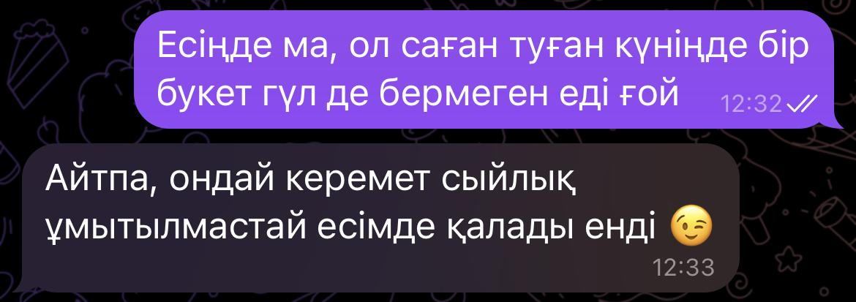

Question: В үшін А-ның сыйлығы есте қалардай керемет болды ма?

Translation:

Speaker A: Do you remember, he did not even give you a bouquet of flowers on your birthday?

Speaker B: Don’t mention, his gift was the best that I will remember forever **😉**

Question: Was A’s gift the best ever for A?

**Chinese:**

**Fillers with Emoji (4):**

1. 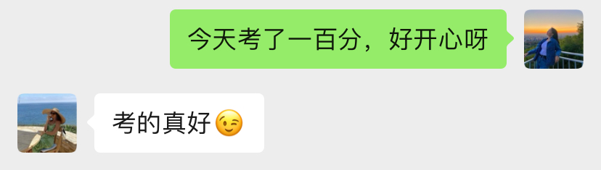

**Question: Does B think A did a great job?**

**Expected Answer: [YES]**

**Translation:**

**A： I got 100 points in the test today. I’m so happy.**

**B：You did really well on the exam 😉**

1. 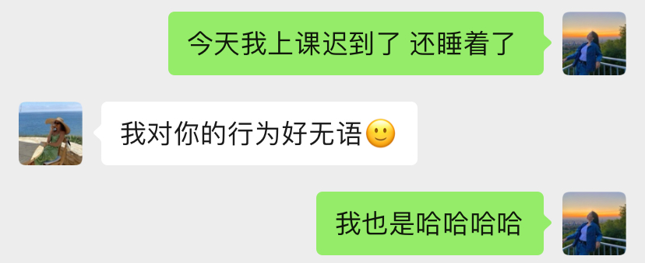

**Question: Does B feel speechless?**

**Expected Answer: [YES]**

**Translation:**

**A： I was late for class today and fell asleep**

**B： I am so speechless at your behavior 🙂**

**A： Me too hahahaha**

1. 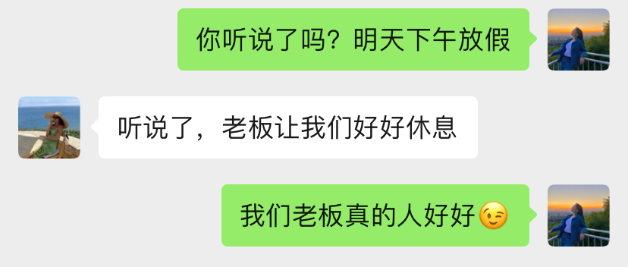

**Question: Does A think the boss is good?**

**Expected Answer: [YES]**

**Translation:**

**A: Did you hear that? Tomorrow afternoon is free**

**B： I heard it, the boss wants us to have a good rest**

**A：Our boss is really nice 😉**

1. 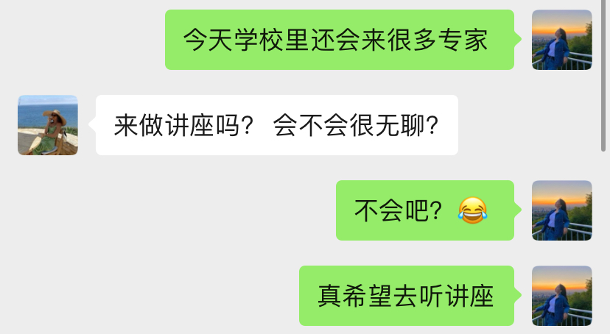

**Question: Does A want to go to the lecture?**

**Expected Answer: [YES]**

**Translation:**

**A： There will be many experts coming to the school today**

**B： Come to give a lecture? Will it be boring?**

**A: No way? 😂**

**A: I hope to attend the lecture**

**Fillers without Emoji (4):**

1. 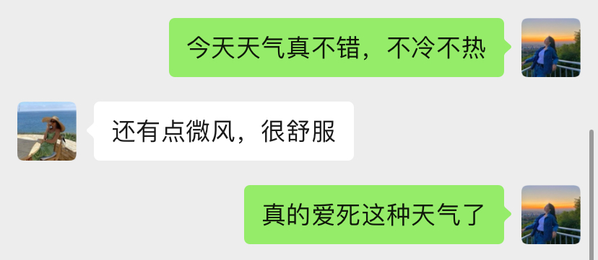

**Question: Does A like this weather?**

**Expected Answer: [YES]**

**Translation:**

**A: The weather is nice today, neither hot nor cold**

**B: There's still a little breeze, which is very comfortable.**

**A: I really love this weather.**

1. 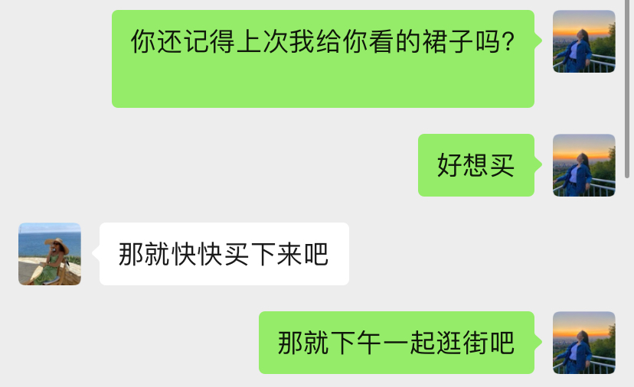

**Question: Does B want A to buy this skirt?**

**Expected Answer: [YES]**

**Translation:**

**A: Do you remember the dress I showed you last time?**

**A: Want to buy**

**B: Then buy it quickly**

**A: Then, let’s go shopping together in the afternoon**

1. 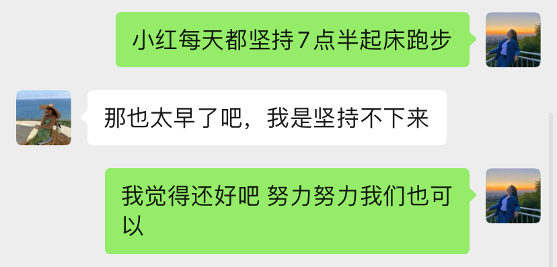

**Question: Does A think it’s early to wake up at 7:30 in the morning?**

**Expected Answer: [YES]**

**Translation:**

**A: Xiaohong keeps on getting up at 7:30 every day to run**

**B: That's too early, I can't keep it**

**A: I think it's okay. We can do it if we work hard.**

1. 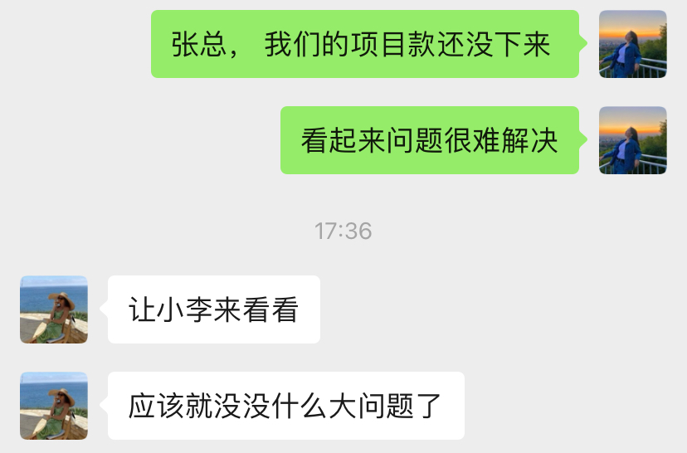

**Question: Does B think there is no big problem?**

**Expected Answer: [YES]**

**Translation:**

**A：Chairman Zhang, the money for our project has not come yet.**

**A：The problem seems difficult to solve**

**B：Let Xiao Li come and take a look**

**B：It should be no problem**

**CHN_STIMULI**

**With emoji 🙂(2)**

**Mild:**

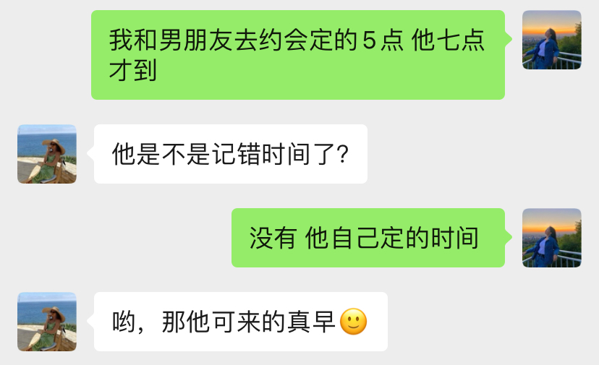

**Strong:**

**Question： Does B think A’s boyfriend arrived early?**

**Expected Answer: [NO]**

**Translation:**

**A: My boyfriend and I went on a date at 5 o'clock and he didn't arrive until 7 o'clock**

**B: Did he remember the wrong time?**

**A: No, he sets this time**

**B: Oh, he came really early then 🙂**

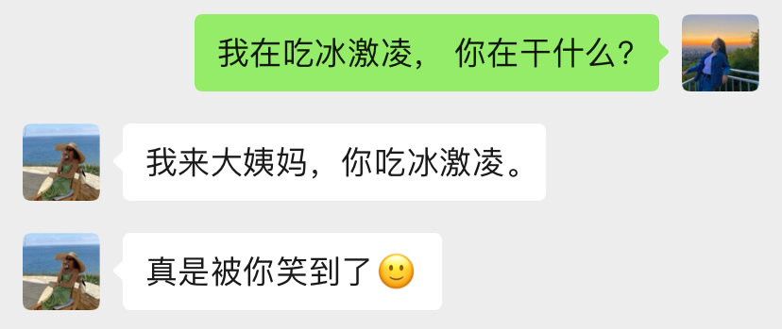

**Translation:**

**Question： Did A make B want to laugh?**

**Expected Answer: [NO]**

**A: I'm eating ice cream, what are you doing?**

**B: I'm on my period, you eat ice cream.**

**B：You really made me laugh 🙂**

**With emoji 😂(2)**

**Mild:**

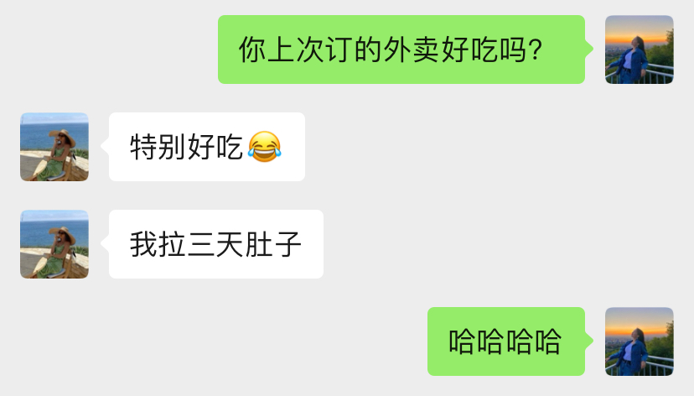

**Question： Does B think the carry out was delicious?**

**Expected Answer: [NO]**

**Translation：**

**A：Did the takeaway you ordered last time taste good?**

**B：Very delicious😂**

**B：I had diarrhea for three days**

**A：Hahahaha**

**Strong:**

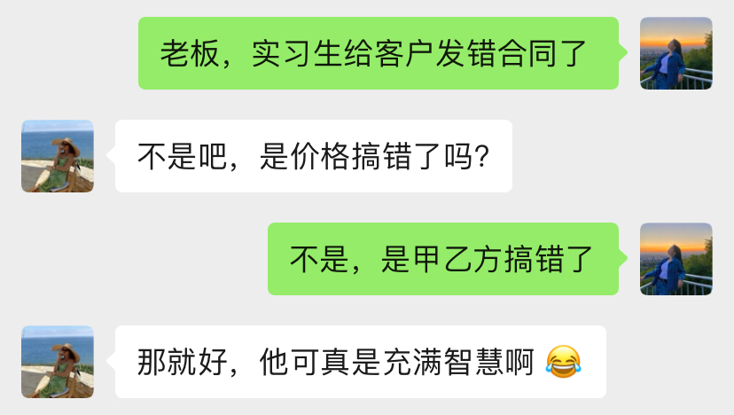

**Question：Does B think A is full of wisdom?**

**Expected Answer: [NO]**

**A：Boss, the intern sent the wrong contract to the client.**

**B：No way, is the price wrong?**

**A：No, Party A and Party B made a mistake**

**B：That’s good, he is really full of wisdom 😂**

**With emoji 😉(2)**

**Mild:**

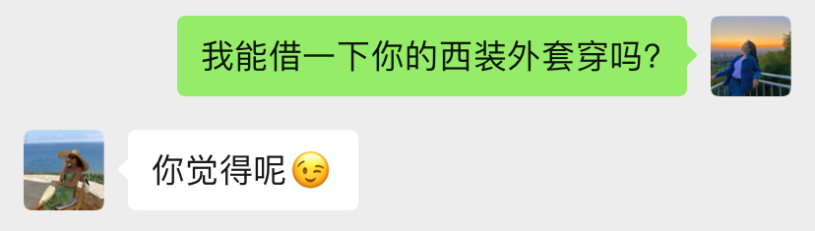

**Question：Does B want to lend A clothes?**

**Expected Answer: [NO]**

**A：Can I borrow your suit jacket?**

**B：How do you think 😉**

**Strong:** 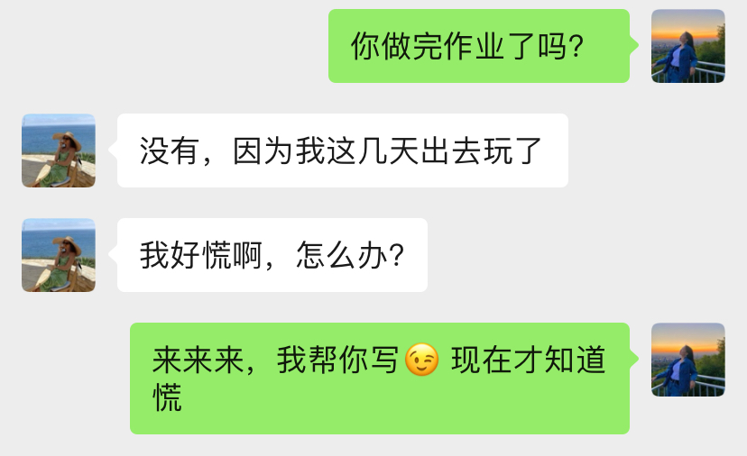

**Question: Will A write the homework for B?**

**Expected Answer: [NO]**

**Translation：**

**A：Have you finished your homework?**

**B：No, because I went out to play these days**

**B：I'm so panicked, what should I do?**

**A：Come on, let me write it for you😉 You Only know to panic now**

**Without emoji (2)**

**Mild: 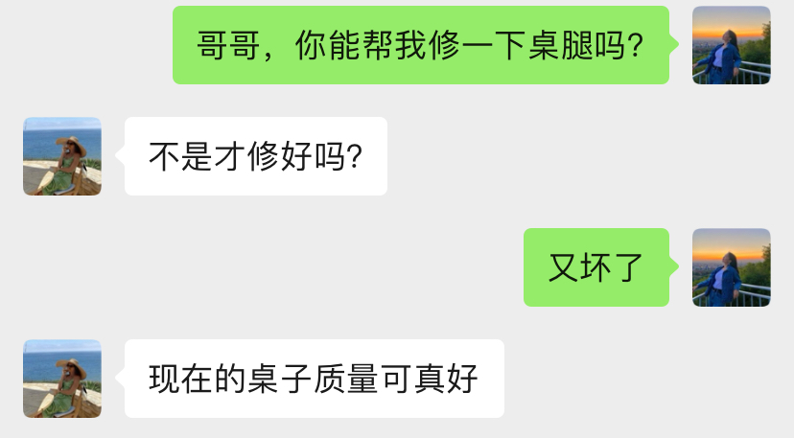Strong:**

**Question: Does B think the tables nowadays are of good quality?**

**Expected Answer: [NO]**

**Translation：**

**A：Brother, can you help me repair the table legs?**

**B：Wasn't it just repaired?**

**A：Broken again**

**B：Nowadays，the quality of the tables are really good**

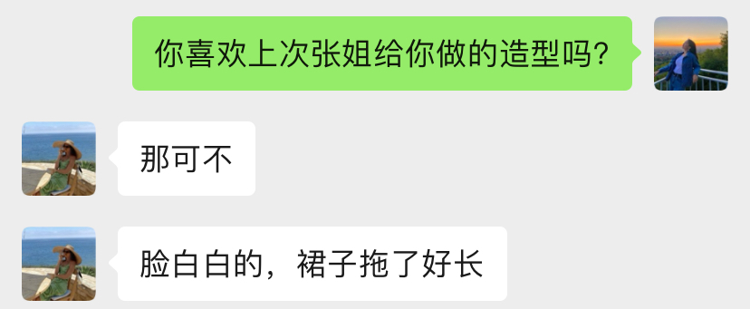

**Question: Did B like the look done by Sister Zhang?**

**Expected Answer: [NO]**

**Translation：**

**A：Do you like the look Sister Zhang gave you last time?**

**B：why not**

**B：My face was too pale and the dress was too long.**